CO2020 – Computer Aided Numerical Methods II
HomeWork 6
Hyperbolic PDEs

Ishaan Jain
CO21BTECH11006

Ans 1.

where for
(a) Explicit euler FTCS scheme:
Let’s say,is the numerical solution:

andis the exact solution:

On subtracting these equations, we get

The error is assumed to be of the form, substituting this,

We have to check for the values where

Here when the equality holds,which is can’t be a solution.
So, the equation is unconditionally unstable.
(b) Lax method:

Let’s say,is the numerical solution:

andis the exact solution:

On subtracting these equations, we get

The error is assumed to be of the form, substituting this,

We have to check for the values where

Hence, the Von Neumann stability analysis concludes that the Lax method is cconditionally stable with the condition being

Ans 2.

While using the lax method,
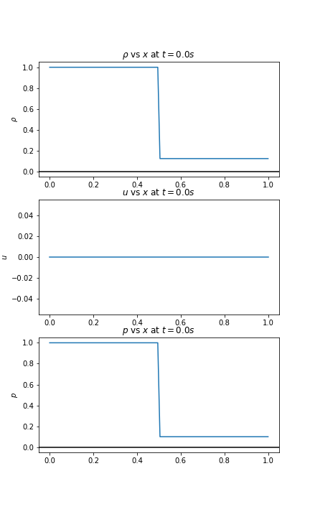
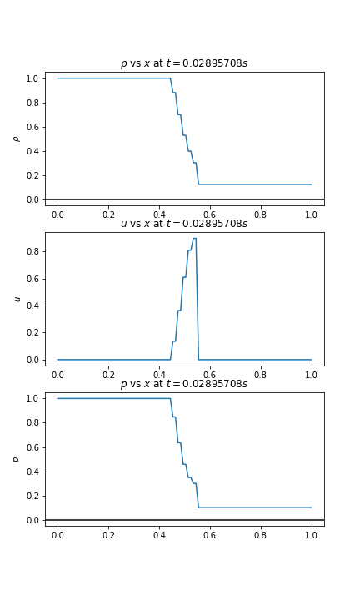
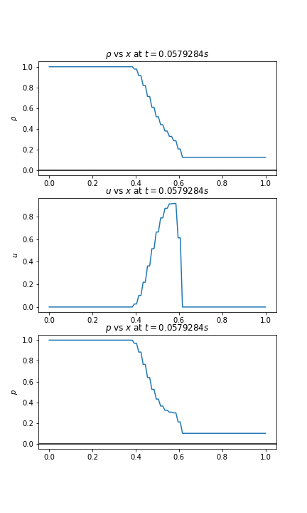
(a) when CFL number is 0.99, we get the follwing profiles of density, velocity and pressure when plotted against x at different time steps.

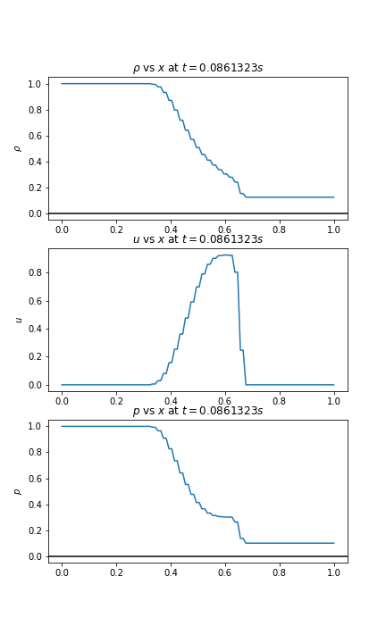
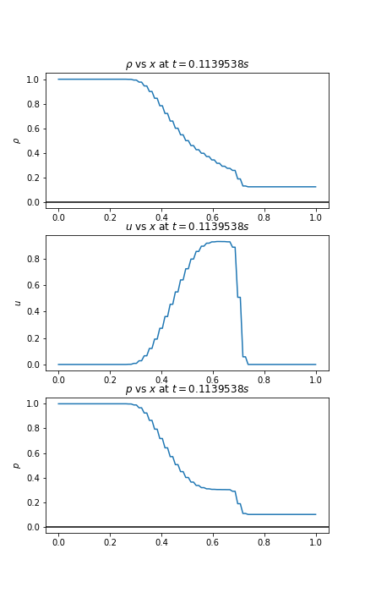
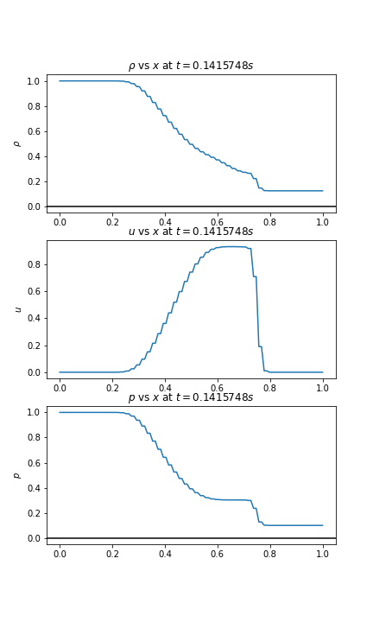

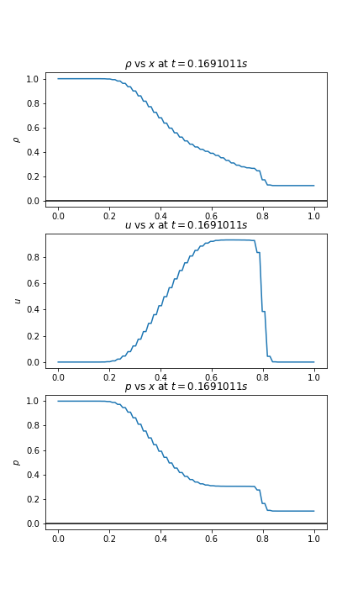
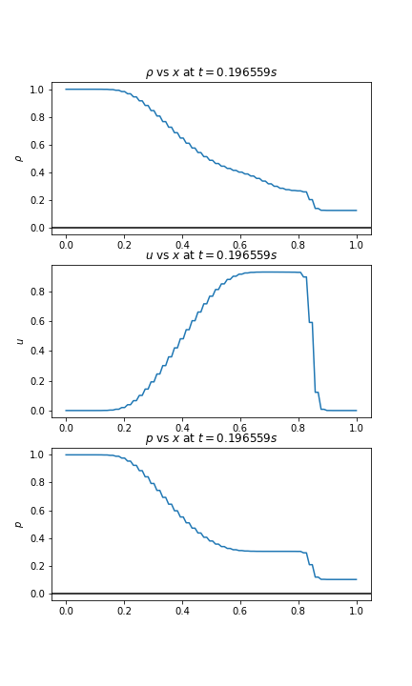
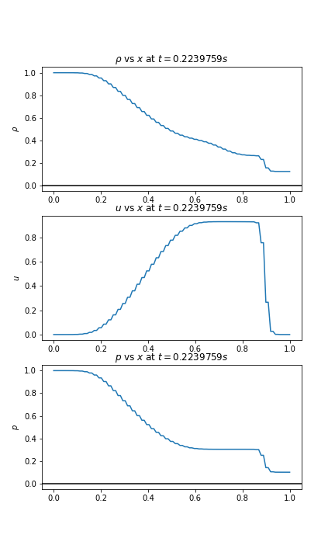
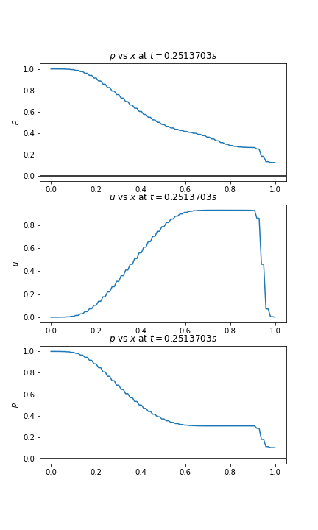

(b) When CFL = 0.3, we get the following profiles:
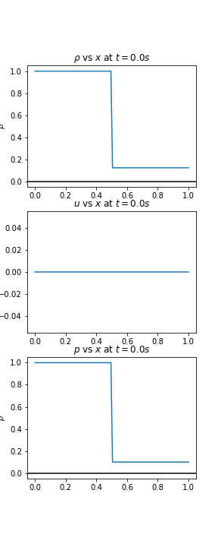
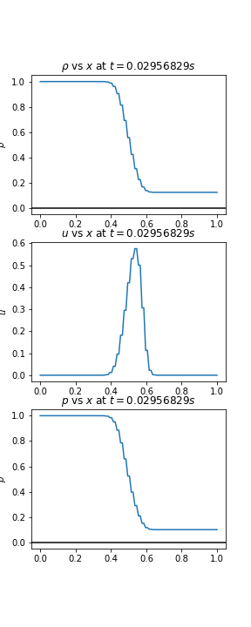
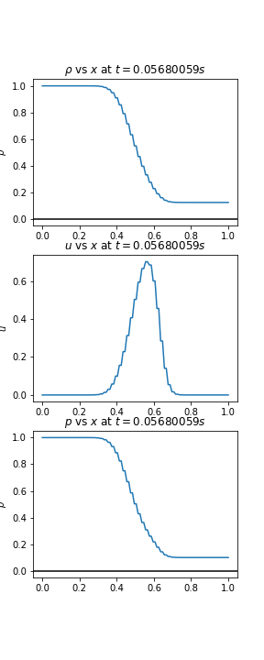
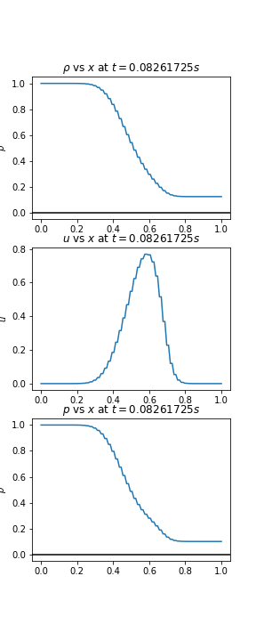

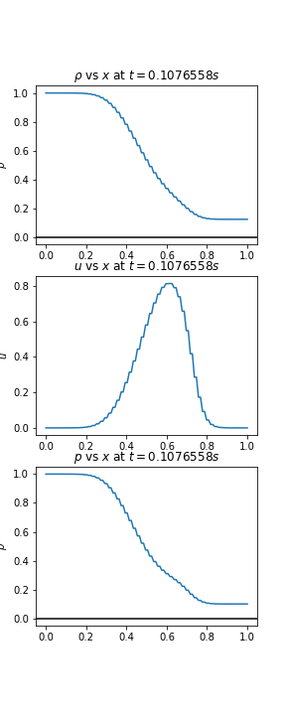
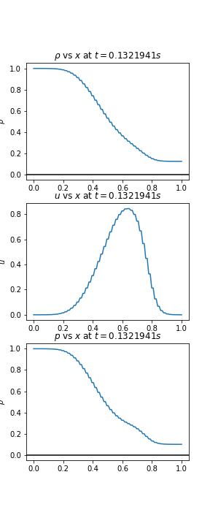
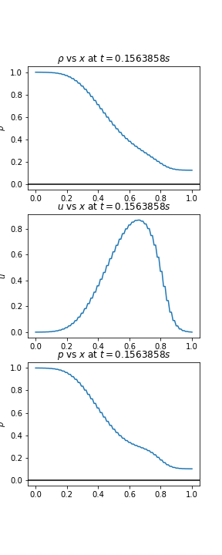
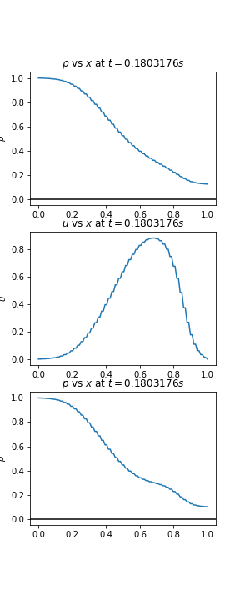

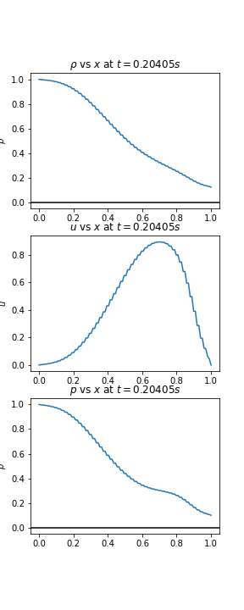
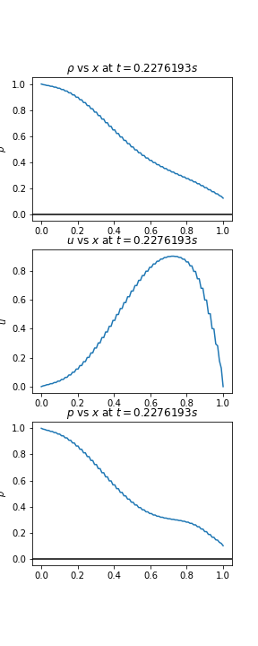
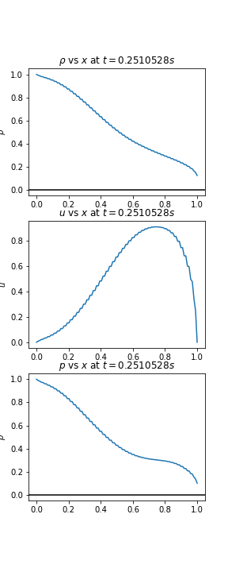

We can observe that the plots for CFL = 0.99 are less stable than CFL = 0.3. The reason is that in the first question itself, we derived that the CFL should be less than or equal to 1. As 0.99 is much closer to 0.3, so the solution when
CFL = 0.99 should have more discontinuity, which is evident from the plots. So, decreasing CFL number results in more stability.

